|  |
| --- |
| Circle Language Spec: System Objects |

## System Interface of an Object

The main thing you see when showing the system interface of an Object is the Related Items & Related Lists collections.

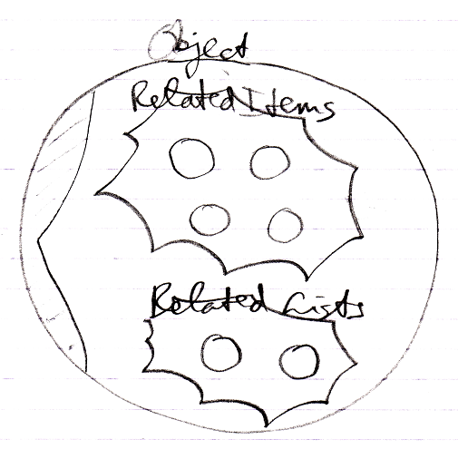

But apart from sub-objects, an object has the following aspects:

- Value

- Class

- Execute

- Clone

- Data

They are controlled through system commands. Those commands will also be visible inside the system interface.

### The Value Aspect in the System Interface

The Value aspect is controlled through two commands:

Value Get

Value Set

The Value aspect is represented by a triangle, that wraps together the members to control the Value aspect:

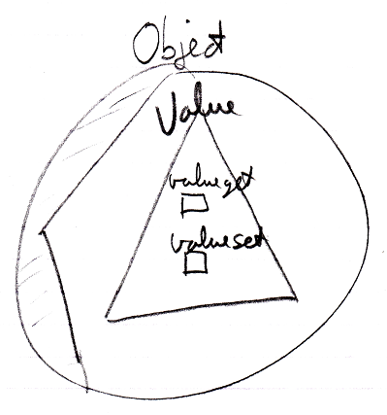

### The Object-Class Aspect in the System Interface

The Class aspect has *five* system commands, but only *two* of them apply to Objects. The other ones apply to references. The Class aspect of an Object is controlled through the following commands:

Use As Class

Object-Class Get

The commands are placed inside a triangle, that wraps together the members of the Class aspect:

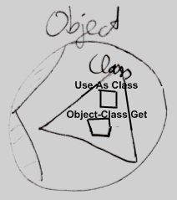

### The Execute Aspect in the System Interface

The Execute aspect only applies to executable objects, also called commands. The Execute aspect only has one command:

Execute

The command is placed inside a triangle, that wraps together the members of the Execute aspect:

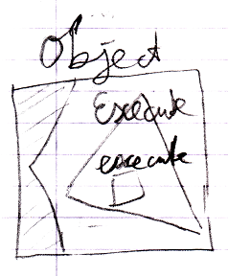

### The Clone Aspect in the System Interface

The Clone aspect is controlled through two commands:

Clone Get

Clone Set

Both commands have a Depth parameter to indicate the cloning depth.

The commands are placed inside a triangle, that wraps together the members of the Clone aspect:

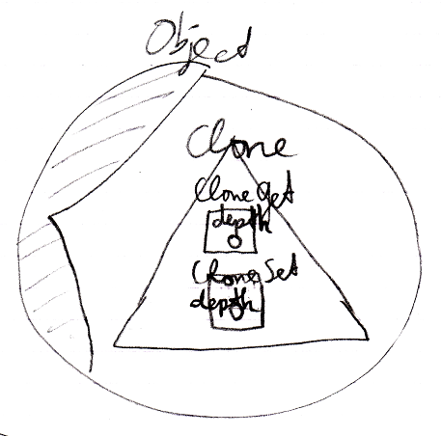

### The Data Aspect in the System Interface

The Data aspect is controlled through two system commands:

Data Get

Data Set

The Data Get and Data Set command can not be called; they can only be access-controlled to control read-write access to the object and all the contents of the object.

The commands are placed inside a triangle, that wraps together the members of the Data aspect:

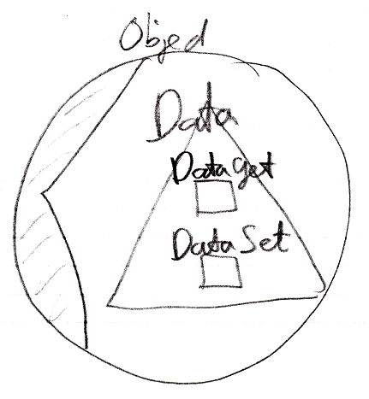

### The Full System Interface for Object

The full system interface of an Object looks like this:

